# MySQL读写分离 MySQL Router

## 准备

### 下载

|  |
| --- |
| wget <https://cdn.mysql.com//Downloads/MySQL-Router/mysql-router-2.1.4-el6-x86-64bit.tar.gz> |

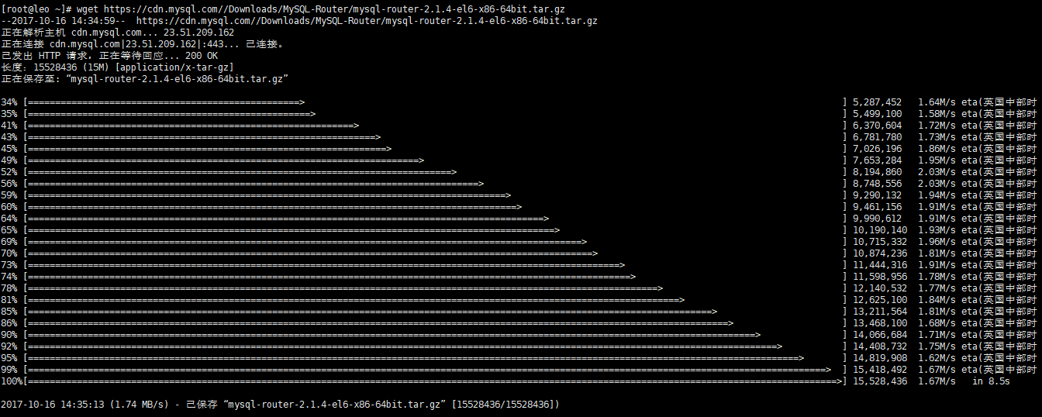

### 解压

|  |
| --- |
| tar -xzvf mysql-router-2.1.4-el6-x86-64bit.tar.gz |

### 移动

|  |
| --- |
| mv mysql-router-2.1.4-el6-x86-64bit /usr/local/mysqlrouter |

## 配置

### 创建logs、etc目录

原目录，新目录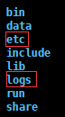

### 根据模板创建新的配置文件

|  |
| --- |
| cp /usr/local/mysqlrouter/share/doc/mysqlrouter/sample_mysqlrouter.conf /usr/local/mysqlrouter/etc/mysqlrouter.conf |

### 修改配置

|  |
| --- |
| [DEFAULT]  logging_folder = /usr/local/mysqlrouter  plugin_folder = /usr/local/mysqlrouter/lib/mysqlrouter  config_folder = /usr/local/mysqlrouter/etc  runtime_folder = /usr/local/mysqlrouter/run  [logger]  level = INFO  [routing:read_write]  bind_address = 192.168.56.102 **#router所在IP**  bind_port = 7001 **#写端口**  mode = read-write  destinations = 192.168.56.102:3306 **#主DB的IP，有多个用,分隔**  [routing:read_only]  bind_address = 192.168.56.102 **#router所在IP**  bind_port = 7002 **#读端口**  mode = read-only  destinations = 192.168.56.103:3306 **#从DB的IP，有多个用,分隔**  [keepalive]  interval = 60 |

别忘了打开iptables的7001、7002端口。

## 启动

进入bin目录

|  |
| --- |
| ./mysqlrouter -c /usr/local/mysqlrouter/etc/mysqlrouter.conf & |

验证

|  |
| --- |
| netstat -tunlp|grep mysqlrouter |

